**GPS TRACKING SYSTEM**

**AND MONITORING PERIPHERALS**

(An IOT and WEB DEVELOPMENT Project)

DEVELOPED AT

**C:\xampp\htdocs\project\images\tata_new.png**

SUBMITTED BY

**AKSHAY VINAYAK**

B.TECH (CSE) SECOND YEAR STUDENT

AMITY UNIVERSITY, KOLKATA

# CERTIFICATE OF APPROVAL

This is to certify that **AKSHAY VINAYAK**, a student of B.TECH fourth semester from **AMITY UNIVERSITY, Kolkata** has worked under my supervision and guidance from **2nd June 2018** to **30th June 2018** and has completed the project for “GPS TRACKING SYSTEM AND MONITORING PERIPHERALS (An IOT and WEB DEVELOPMENT Project)” successfully.

We appreciate his enthusiasm and commitment during the project tenure and wish him success in his future endeavours.

Mr. Krishna Singh Mrs Nilanjana Mohanty

(Project Mentor) (Associate Human Resource)

# Mr. Pralay Pal

(Project Manager)

**ACKNOWLEDGEMENT**

*It has been a great honour and privilege to undergo training at* ***Tata Technologies Ltd., Jamshedpur****. I have been able to complete this project only due to the kind support and guidance of many individuals. However, it would be wrong on my part to not express my sincere thanks to all of them.*

*I would like to take opportunity to express my humble gratitude to* ***Mr. Pralay Pal*** *who has helped to me execute this project. His constant guidance and willingness to share his vast knowledge made understand this project and its manifestations in great depth. I am highly obliged to my project guide* ***Mr. Krishna Singh*** *without whose support this work would not have been accomplished. His invaluable guidance helped me understand the project better.*

*I am grateful to* ***Mrs Nilanjana Mohanty****, the Human resources manager for providing all the facilities to meet my project requirements and giving me a chance to work with this organization.*

*Lastly, I thank my parents for being a constant support throughout my work. Although there may be many who remain unacknowledged in this humble note of gratitude, there are none who remain unappreciated.*

**TABLE OF CONTENTS**

|  |  |  |
| --- | --- | --- |
| SNO | CONTENTS | PAGE NO |
| 1 | Overview Of Organization | 5 |
| 2 | Introduction Of Project | 6 |
| 3 | Project On IOT | 7 |
| 4 | System Environment | 8 |
| 5 | Description of Software | 9 |
| 6 | Data Flow Description/ Diagram | 10 |
| 7 | Project | 13 |
| 8 | Output and List Of Figures | 29 |
| 9 | Advantages | 33 |
| 10 | Disadvantages | 35 |
| 11 | Conclusion | 36 |
| 12 | Bibliography | **37** |

**OVERVIEW OF ORGANISATION**

Tata Technologies is India's leading specialist engineering & Design (E&D) company, employing more than 80% local talent in its operation across 12 countries. It is India's first truly global E&D service provider. The Tata Technologies Group helps great manufacturers create great products.

Through its operating companies, Tata Technologies, the Tata Technologies Group is an emerging world leader in the provision of specialized IT-enabled consulting, services and products to leading manufacturers. It responds to customers' needs through its operations across 12 countries on three continents and through its offshore development centers in India and Thailand. The Group's customers are among the world's premier automotive, aerospace and consumer durable manufacturers.

Tata Technology is the world's leading independent global professional services company engaged in Product & Information Lifecycle Management, Engineering & Design Services, Enterprise Solutions and Plant Automation. Tata Technology focuses on enabling manufacturers to improve revenue and profit by realizing a superior product portfolio.

Their services include product design, analysis and production engineering; Knowledge Based Engineering; product lifecycle management, enterprise resource planning and customer relationship management systems. Tata Technology also distributes, implements and supports PLM products from world leading solution providers such as IBM/Dassault Systems, UGS and Auto Design.

The group works across multiple domains, including:

* SAP
* Product Design
* Vehicle Architecture
* Advanced Engineering
* Vehicle CAE
* Body Structures
* Exteriors and Interiors
* Chassis
* Power train
* Electrical
* Digital Manufacturing
* PLM & IT

**INTRODUCTION OF PROJECT**

Our project is on GPS tracking system and monitoring peripherals for company vehicle. This is an IOT and WEB DEVELOPMENT project that helps us track the real time position and condition of vehicles. The Global Positioning System (GPS) is a satellite-based navigation system that consists of 24 orbiting satellites, each of which makes two circuits around the Earth every 24 hours. These satellites transmit three bits of information – the satellite's number, its position in space, and the time the information is sent. These signals are picked up by the GPS receiver, which uses this information to calculate the distance between it and the GPS satellites.

With signals from three or more satellites, a GPS receiver can triangulate its location on the ground (i.e., longitude and latitude) from the known position of the satellites. With four or more satellites, a GPS receiver can determine a 3D position (i.e., latitude, longitude, and elevation). In addition, a GPS receiver can provide data on your speed and direction of travel. Anyone with a GPS receiver can access the system. Because GPS provides real-time, three-dimensional positioning, navigation, and timing 24 hours a day, 7 days a week, all over the world, it is used in numerous applications, including GIS data collection, surveying, and mapping.

Hence forth by using this technology we are able to locate the real time position of the vehicles that are dispatched for testing over the test tracks, by locating we mean not only the position or location of the vehicle but also the speed per Km according to time interval, gaining access over peripherals like engine, suspensions, fuel tank, brakes etc. help us gain more stability over the field of manufacturing vehicles.

This also insures safety for the vehicles that are on fields for testing and that the components are working fine. By doing this we not just save time but manufacture quality products to our customers.

**PROJECT ON IOT**

**What is IOT?**

The Internet of Things (IOT) is many things to many people. It means a fundamental change in the way mobile network operators, build and manage networks to remain profitable.

The Internet of Things (IOT) is the network of physical devices, vehicles, home appliances and embedded with [electronics](https://en.wikipedia.org/wiki/Electronics), [software](https://en.wikipedia.org/wiki/Software), [sensors](https://en.wikipedia.org/wiki/Sensor), [actuators](https://en.wikipedia.org/wiki/Actuator), and [connectivity](https://en.wikipedia.org/wiki/Internet_access) which enables these things to connect and exchange [data](https://en.wikipedia.org/wiki/Data) creating opportunities for more direct integration of the physical world into computer-based systems, resulting in efficiency improvements, economic benefits and reduced human intervention.

According to Cisco “The Internet of Things is the intelligent connectivity of physical devices driving massive games in efficiency business growth and quality of life.”

**Why IOT is needed?**

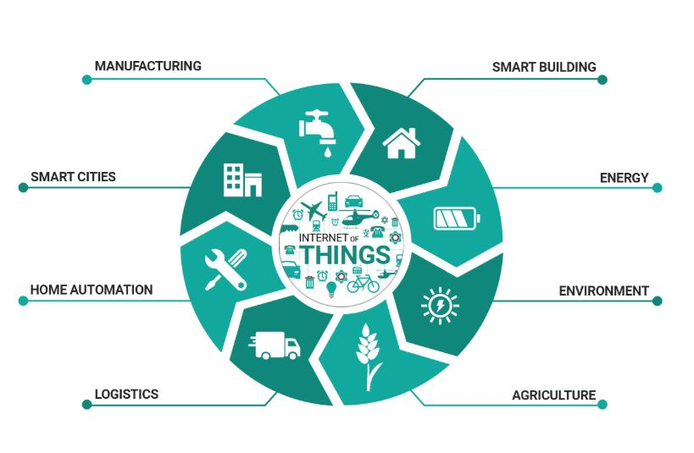IOT in modern era is capable of making things easier for a living by making every aspect of human world automated. It is needed in many fields such as:

* Environmental Monitoring
* Infrastructure Management
* Industrial Applications
* Energy Management
* Medical and Healthcare Systems
* Building and Home Automation
* Transport Systems
* Large Scale Deployments
* Connectivity
* People and processes

**How large is the IOT market?** Fig 1: Power of IOT

In the not too distant future hundreds of millions and billions of individual and business with billions then trillions of smart communicating devices will stretch the boundaries of current system creating the potential to change the way we work learn entertain and innovate in 2014 nearly two billion connected device what shift but now till 2020 this number will grow nearly to eight million devices.

**SYSTEM ENVIRONMENT**

**Operating System:**

Windows

**Software Used:**

IDE: Arduino IDE

Wamp Control Panel V3.2.2

Front-End: HTML, PHP

Database (Backend): MySQL

Integrated Development Environment: Notepad++

Note: Best viewed in Internet Explorer 6.0+ / Netscape 6.2.3+ / Mozilla 1.4+ / Firefox 1.5+ / Safari 5.0+ / Chrome with 1024 X 768 resolution.

**DESCRIPTION OF SOFTWARE**

**ARDUINO IDE:**

IDE stands for integrated development environment. Arduino software (IDE) enables the user to write their code and upload it in the board. This software is open source software and can work on Mac, windows and Linux. The environment of the system is basically scripted in java which makes it platform independent. This software is independent of any Arduino board. The basic programming language or you call it the Arduino language is C++ or C. An IDE normally consists of a source code editor, build automation tools, and a debugger. Most modern IDE’s have intelligent code completion.

**SQL:**

It stands for structured query language. It is domain specific language which has its implementation in programming and designed for managing data held in a relational database management system (RDBMS). It is especially useful in handling structured data where there are relations between different entities of the data. The scope of SQL includes data query, data manipulation, data definition and data access control.SQL was one of the first commercial languages but now has become the most widely used database language.

Listed below are features of SQL-

* High performance.
* High availability.
* High security.
* Management ease and open source.
* Robust transactional support.

**PHP:**

It is abbreviation as Hypertext Pre-processor. It is a programming language which enables users to create dynamic content which interacts with the databases. It is basically designed for developing web based software applications(precisely a server side scripting language for web developers).PHP can be deployed on most web servers, many operating systems and platforms, and can be used with many relational database management systems(RDBMS).

PHP acts primarily as a filter, taking input from a file or stream containing text and PHP instructions and outputting another stream of data. Originally designed to create dynamic web pages, PHP now focuses mainly on server-side scripting. From security point of view, it is dependable as the technical flaws of the language itself are not frequent. This language also provides taint checking and several other features.

**DATA FLOW DESCRIPTION**

DFD is a method used to illustrate the flow of data in a system. It is one of the most important modeling tools used by system designers to understand the system. As information moves through software, it is modified by a series of transformations. A DFD is a graphical technique that depicts information flow and transformations that are applied as data moves from input to output. The DFD provides the mechanism or functional modeling as well as information flow modeling.

# NOTATION:

**Data Flow:**

Data-Flows show the movement of data in a specific direction. It represents a packet of data.

Image

# PROCESS:

Processes show the operations performed on the data, which transforms it from input to output.



# EXTERNAL ENTITY:

Sources and destinations of data are the external sources and the destinations of data, which may be people, programs, organizations and other entities interacting with the system but are outside its boundary.



# DATA STORE:

Data Stores are places where data are stored such as files and tables.

Image

Image

# OUTPUT:

The output symbol is used when a hard copy is produced.

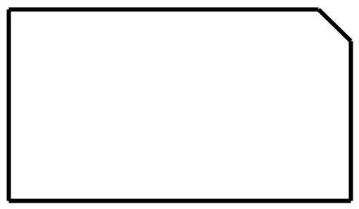

**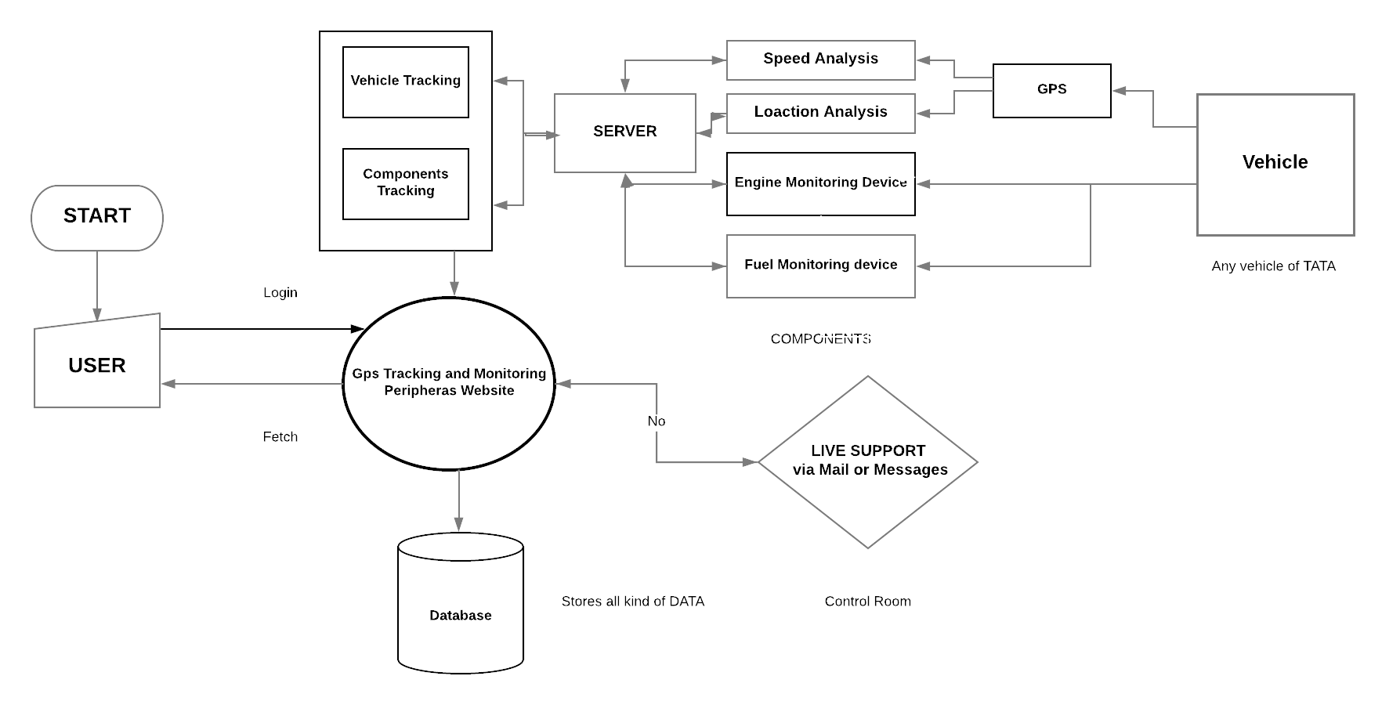DATA FLOW DIAGRAM**

Fig 2: Flow chart of the System and device

**DESCRIPTION:**

When the device is turned on the components are active and we can have a track of them via server. This is the flow chart of the server how it works. We start the server and the full access is gained by the Admin, the Admin authorizes a worker to operate upon the server and have an eye on the vehicle going out for test tracks.

Now, the Website consists of vehicle tracking and components tracking systems, which is a platform for monitoring where the vehicle is and in what condition is it operating. The devices connected send data over server and the user fetch those data for further processing.

There is a live support added to the website so that if there is any problem occurred in the field or website the worker can connect with the admin for solutions.

**PROJECT**

**AIM:** GPS Tracking System and Monitoring Peripherals

**THEORY:**

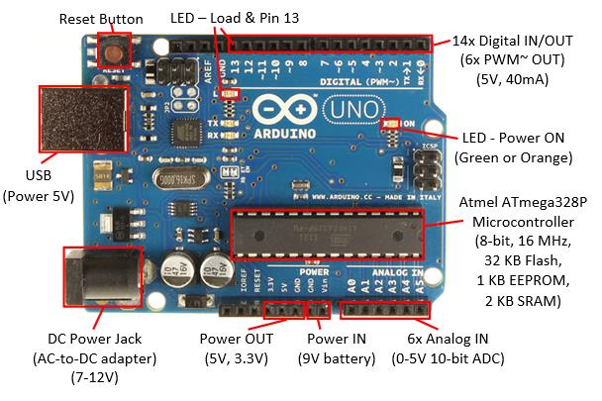The project consists of:

* **ARDUINO UNO**

ARDUINO is an open-source platform used for building electronics projects. Arduino consists of both a physical programmable circuit board (often referred to as a [microcontroller](http://en.wikipedia.org/wiki/Microcontroller)) and a piece of [software](http://arduino.cc/en/Main/Software), or IDE (Integrated Development Environment) that runs on your computer, used to write and upload computer code to the physical board. Fig 3: Arduino UNO Guino board

* **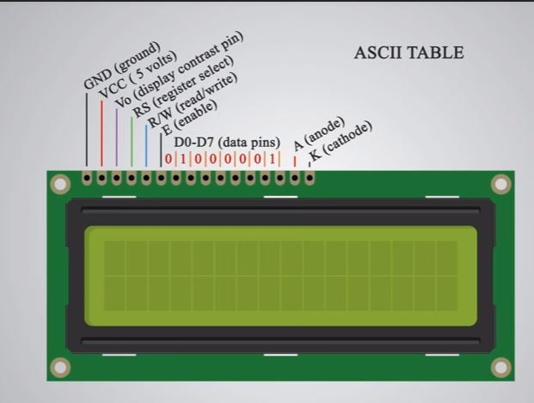LCD RG1602A**

LCD stands for "Liquid Crystal Display." LCD is a flat panel display technology commonly used in TVs and computer [monitors](https://techterms.com/definition/monitor). It is also used in screens for mobile devices, such as [laptops](https://techterms.com/definition/laptop), [tablets](https://techterms.com/definition/tablet), and [smart phones](https://techterms.com/definition/smartphone). We have used LCD RG1602A to display our messages.

* **JUMPER WIRES** Fig 4: LCD 16x2 display unit

Jumper wires are simply wires that have connector pins at each end, allowing them to be used to connect two points to each other without soldering. Jumper wires are typically used with [breadboards](https://blog.sparkfuneducation.com/what-is-a-breadboard) and other prototyping tools in order to make it easy to change a circuit as needed.

Jumper wires typically come in three versions: male-to-male, male-to-female and female-to-female. The difference between each is in the end point of the wire. Male ends have a pin protruding and can plug into things, while female ends do not and are used to plug things into. Male-to-male jumper wires are the most common and what you likely will use most often. When connecting two ports on a breadboard, a male-to-male wire is what you’ll need.

* **BREAD BOARD**

It is basically just a piece of plastic with a bunch of holes in it. However, the magic lies within where a bunch of metal strips connect the rows of holes. These strips of metal have little clips that match up to the holes in the top of the breadboard and hold wires and components in place-as well as create electrical connections to anything else placed in the same row.

In addition to the horizontal rows, most breadboards feature vertical power rails that allow for easy access to power wherever it is needed within the circuit. Usually they will be labelled with a ‘+’ and a ‘-’ and have a red stripe and a blue or black stripe to indicate the positive and negative side.

* **WIFI-MODULE ( NODE MCU board (ESP8266))**

ESP8266-Based Serial WiFi Shield for Arduino is designed and developed by Shenzhen Doctors of Intelligence & Technology (SZDOIT). The shield is designed based on esp8266 by Espressif Systems, pin-compatible with Arduino UNO/Mega2560 DevBorad.

The serial wifi shield has the following features:

1、WiFi module is industrial-grade chips ESP8266, which is ESP-12E with metal shield, strong anti-interference ability;

2, Shield is pin-compatible with Arduino Uno, Mega2560 and other control board. A voltage converter chip is used to deal with 3.3V (Esp8266) and 5V (Arduino);

3, Dual DIP switches is used for serial ports so that this module shield can be used alone as an Arduino Uno expansion board, and also be used as ESP8266 expansion board;

4, Serial data is transported to WiFi device transparently, and vice versa. Arduino program does not need any configuration;

5, Web Server is developed to configure WiFi parameters and serial port parameters;

6, the module shield can be used as an independent ESP8266 development board. For instance, downloading the official AT commands firmware, NodeMCU open source firmware can be used;

7, the module shield also can be used as stand-alone expansion board for Arduino Uno.

* **GPS MODULE (NEO-6M-0-01)**

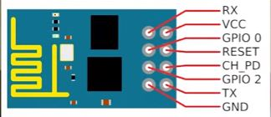GPS stands for Global Positioning System by which anyone can always obtain the position information anywhere in the world. They are found in most smart phones, many new automobiles, and they are used to track commerce all over the globe. These tiny devices can instantaneously give our exact position and time, almost anywhere on the planet, for free! All you need is a GPS receiver and receivers are getting less expensive and smaller every day.

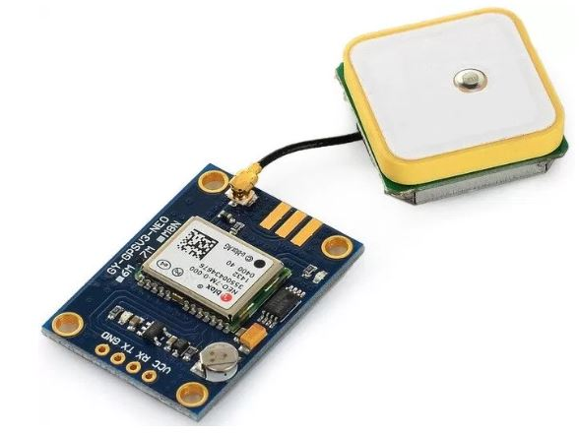Fig 5: GPS Module Fig 6: WI-FI Shield

**THINGS REQUIRED:**

1. ARDUINO UNO

2. BREAD BOARD

3. JUMPER WIRES

4. LCD (RG1602A)

4. WIFI SHIELD (Generic board (ESP8266))

5. GPS MODULE (NEO-6M-0-01)

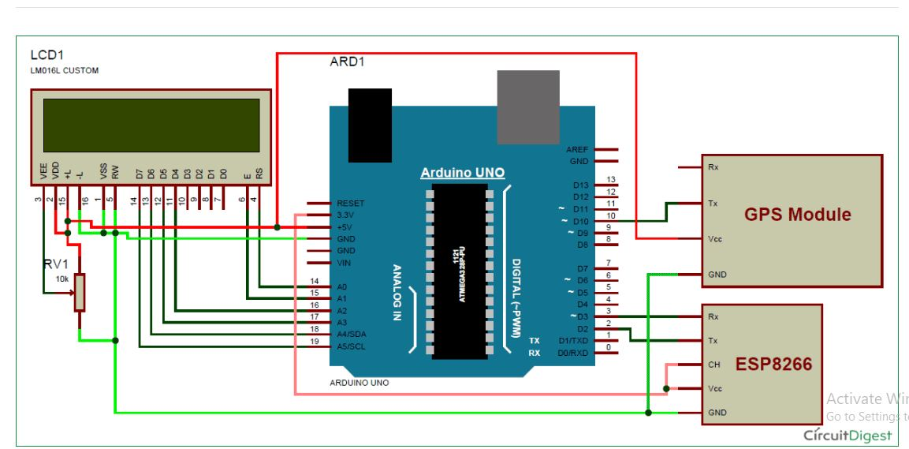Fig 7: Architecture of the system (Connections)

**PROGRAM SNIPPET:**

#include<SoftwareSerial.h>

SoftwareSerial Serial1(0,1); //make RX arduino line is pin 0, make TX arduino line is pin 1.

SoftwareSerial gps(0,1);

#include<LiquidCrystal.h> // **LIQUID CRISTAL DISPLAY**

LiquidCrystal lcd(14,15,16,17,18,19);

boolean No\_IP=false;

String IP="";

String webpage="";

int i=0,k=0;

int gps\_status=0;

String name="<p>1. Name: Your Name </p>"; //22

String dob="<p>2. DOB: 12 feb 1993</p>"; //21

String number="<p>4. Vehicle No.: RJ05 XY 4201</p>";//29

String cordinat="<p>Coordinates:</p>"; //17

String latitude="";

String logitude="";

String gpsString="";

char \*test="$GPGGA";

void check4IP(int t1) // **WIFI SHIELD connecting to WEB SERVER**

{

int t2=millis();

while(t2+t1>millis())

{

while(Serial1.available()>0)

{

if(Serial1.find("WIFI GOT IP"))

{

No\_IP=true;

}

}

}

}

void get\_ip() // **IP\_ Address is thrown**

{

IP="";

char ch=0;

while(1)

{

Serial1.println("AT+CIFSR");

while(Serial1.available()>0)

{

if(Serial1.find("STAIP,"))

{

delay(1000);

Serial.print("IP Address:");

while(Serial1.available()>0)

{

ch=Serial1.read();

if(ch=='+')

break;

IP+=ch;

}

}

if(ch=='+')

break;

}

if(ch=='+')

break;

delay(1000);

}

lcd.clear(); // **LCD clears the previous outputs**

lcd.print(IP); // **LCD prints the IP**

lcd.setCursor(0,1);

lcd.print("Port: 80");

Serial.print(IP);

Serial.print("Port:");

Serial.println(80);

delay(1000);

}

void connect\_wifi(String cmd, int t) // **connecting to WIFI**

{

int temp=0,i=0;

while(1)

{

Serial.println(cmd);

Serial1.println(cmd);

while(Serial1.available()>0)

{

if(Serial1.find("OK"))

{

i=8;

}

}

delay(t);

if(i>5)

break;

i++;

}

if(i==8)

{

Serial.println("OK");

}

else

{

Serial.println("Error");

}

delay(1000);

}

void setup() // **SETUP begins here**

{

Serial1.begin(9600);

Serial.begin(9600);

lcd.begin(16,2);

lcd.print("Vehicle Tracking");

lcd.setCursor(0,1);

lcd.print(" System ");

delay(2000);

lcd.clear();

lcd.print("WIFI Connecting..");

// lcd.setCursor(0,1);

// lcd.print("Please Wait...");

delay(1000);

connect\_wifi("AT",1000);

connect\_wifi("AT+CWMODE=3",1000);

connect\_wifi("AT+CWQAP",1000);

connect\_wifi("AT+RST",5000);

check4IP(5000);

if(!No\_IP)

{

Serial.println("Connecting Wifi....");

connect\_wifi("AT+CWJAP=\"Android AP\",\"12345678\"",7000);

//AT+CWJAP=”wifi\_username”,”wifi\_password”

}

else

{

}

Serial.println("Wifi Connected");

lcd.clear();

lcd.print("WIFI Connected");

delay(2000);

lcd.clear();

lcd.print("Getting IP");

get\_ip();

delay(2000);

connect\_wifi("AT+CIPMUX=1",100);

connect\_wifi("AT+CIPSERVER=1,80",100);

Serial1.end();

lcd.clear();

lcd.print("Waiting For GPS"); //**GPS module is signalled**

lcd.setCursor(0,1);

lcd.print(" Signal ");

delay(2000);

gps.begin(9600);

get\_gps();

show\_coordinate(); // **GPS module shows coordinates**

gps.end();

Serial1.begin(9600);

delay(2000);

lcd.clear();

lcd.print("GPS is Ready");

delay(1000);

lcd.clear();

lcd.print("System Ready");

Serial.println("System Ready..");

}

void loop()

{

k=0;

Serial.println("Please Refresh Ur Page");

lcd.setCursor(0,0);

lcd.print("Please Refresh ");

lcd.setCursor(0,1);

lcd.print("Your Web Page.. ");

while(k<1000)

{

k++;

while (Serial1.available())

{

if (Serial1.find("0,CONNECT"))

{

Serial1.end ();

gps.begin(9600);

get\_gps();

gps.end();

Serial1.begin(9600);

Serial1.flush();

/\* lcd.clear();

lcd.print("Sending Data to ");

lcd.setCursor(0,1);

lcd.print(" Web Page ");\*/

Serial.println("Start Printing");

Send();

show\_coordinate();

Serial.println("Done Printing");

delay(5000);

lcd.clear();

lcd.print("System Ready");

delay(1000);

k=1200;

break;

}

}

delay(1);

}

}

void gpsEvent() // **GPS module**

{

gpsString="";

while(1)

{

while (gps.available()>0) //**Serial incoming data from GPS**

{

char inChar = (char)gps.read();

gpsString+= inChar; //**store incoming data from GPS to temporary string str[]**

i++;

if (i < 7)

{

if(gpsString[i-1] != test[i-1]) //**check for right string**

{

i=0;

gpsString="";

}

}

if(inChar=='\r')

{

if(i>65)

{

gps\_status=1;

break;

}

else

{

i=0;

}

}

}

if(gps\_status)

break;

}

}

void get\_gps() // **Getting coordinates from GPS**

{

gps\_status=0;

int x=0;

while(gps\_status==0)

{

gpsEvent();

int str\_lenth=i;

latitude="";

logitude="";

coordinate2dec();

i=0;x=0;

str\_lenth=0;

}

}

void show\_coordinate() // **Displaying coordinates in LCD**

{

lcd.clear();

lcd.print("Latitide:");

lcd.print(latitude);

lcd.setCursor(0,1);

lcd.print("Longitude:");

lcd.print(logitude);

Serial.print("Latitude:");

Serial.println(latitude);

Serial.print("Longitude:");

Serial.println(logitude);

}

void Send()

{

webpage = "<h1>GPS TRACKING SYSTEM | A TTL PROJECT</h1><body bgcolor=f0f0f0>";

webpage+=coordinates;

webpage+="<p>Latitude:";

webpage+=latitude;

webpage+="</p>";

webpage+="<p>Longitude:";

webpage+=logitude;

webpage+="</p>";

webpage+="<p>for more details visit"; // **VISITING THE SITE**

webpage+="</p>";

webpage+= "<a href=\"http://gps.bitumish.in"; // **GPS TRACKING SYSTEMS**

webpage+=latitude;

webpage+='+'; //**28.612953, 77.231545 //28.612953,77.2293563 a data extracted**

webpage+=logitude;

webpage+="\">Click Here for google map</a>";

sendwebdata();

webpage="";

while(1)

{

Serial.println("AT+CIPCLOSE=0");

Serial1.println("AT+CIPCLOSE=0");

while(Serial1.available())

{

//Serial.print(Serial1.read());

if(Serial1.find("0,CLOSE"))

{

return;

}

}

delay(500);

i++;

if(i>5)

{

i=0;

}

if(i==0)

break;

}

}

void sendwebdata()

{

i=0;

while(1)

{

unsigned int l=webpage.length();

Serial1.print("AT+CIPSEND=0,");

Serial1.println(l+2);

Serial.println(l+2);

Serial.println(webpage);

Serial1.println(webpage);

while(Serial1.available())

{

if(Serial1.find("OK"))

{

return;

}

}

i++;

if(i>5)

i=0;

if(i==0)

break;

delay(200);

}

}

**PROGRAM DESCRIPTION:**

The program deals with all the components installed i.e. Arduino Board, LCD Module, GPS Module, Wi-Fi shield according to their functions written. LCD Module displays all the connection data and the coordinates as per requirement; where as GPS Module gives the location of the vehicle. Now WIFI shield is installed so that we can connect the device to the cloud and get the instant data anytime anywhere, WIFI shield helps throw the IP address of the system in which it is installed so as to visit the web address. All these components are programmed over the Arduino UNO board. Hence the GPS Tracking System is ready to serve the needs of people.

**MONITORING PERIPHERALS**

As explained in the Data-Flow-Diagram this is place where we deal with the components of the vehicle. We are keeping an eye on the various components of the vehicle so as to minimise the drawbacks caused in this field, such as Theft of fuel, Theft of components, failure of the components, safety form any hazard and managing drivers behaviour. Now it is up to the company that which component to monitor for quality products.

For Example: Monitoring of Fuel

When the vehicle is dispatched from the company and as the GPS is turned on the tracking of vehicle and components begin, in the fuel tank there is dipped a calibrated stick which consists of a chip that monitors the fuel level and sends signal to the device via server, Now this device in every time interval sends the fuel level to the server form where we can judge that fuel is decreasing in a constant rate. If not so, say a rapid decrease in fuel level will impact the control unit that something is wrong! Henceforth we can check what the matter is.

There are many advantages of tracking the behaviour of components which can give advancement to the company for better productivity of vehicles. Advantage of monitoring the components is enlisted below.**OUTPUT AND LIST OF FIGURES**

**OUTPUT FROM THE PROGRAM:**

**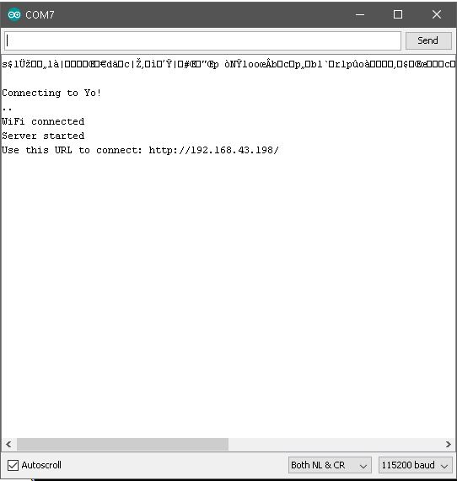**

Fig 8: COM port output

**LINK FOR SITE:**

**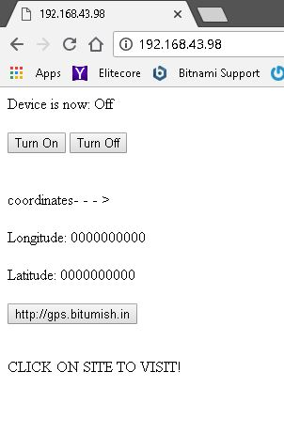**

Fig 9: Visiting the site

**VISITING THE SITE:**

**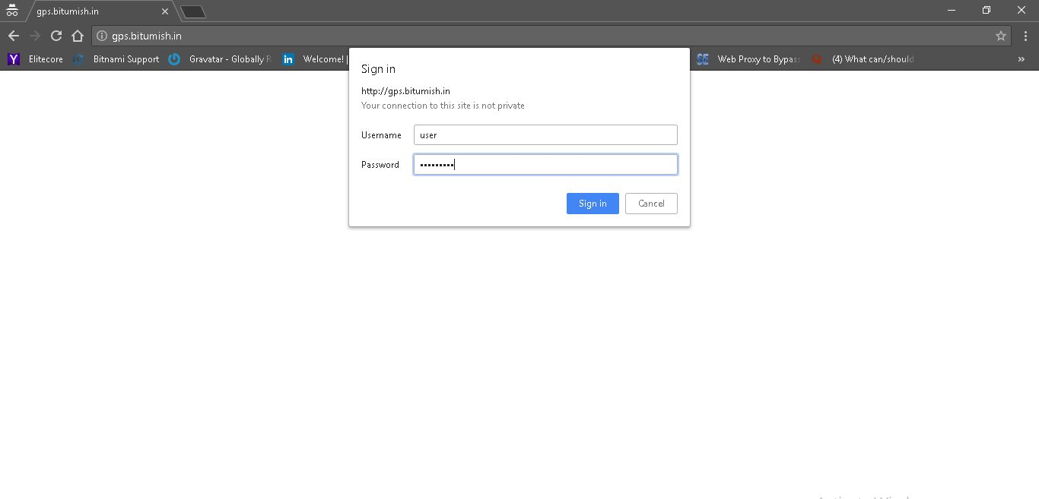**

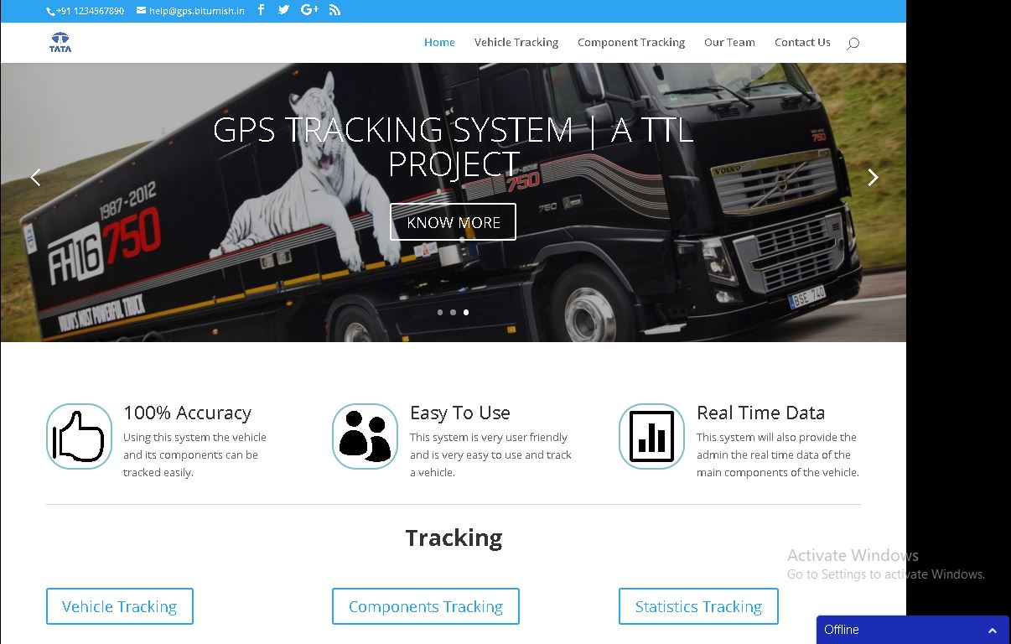 Fig 10: Sign in/ log in

Fig 11: Home page of site

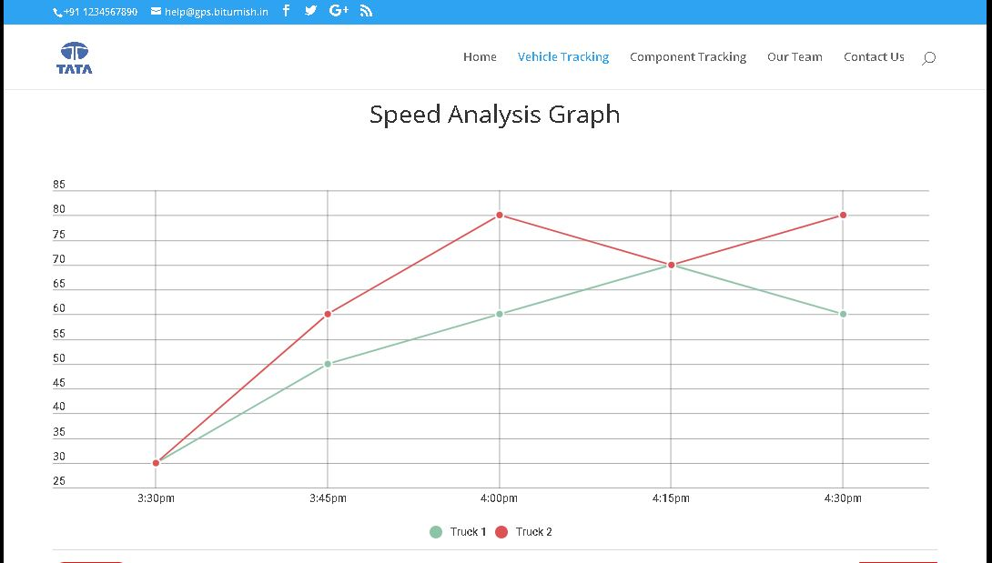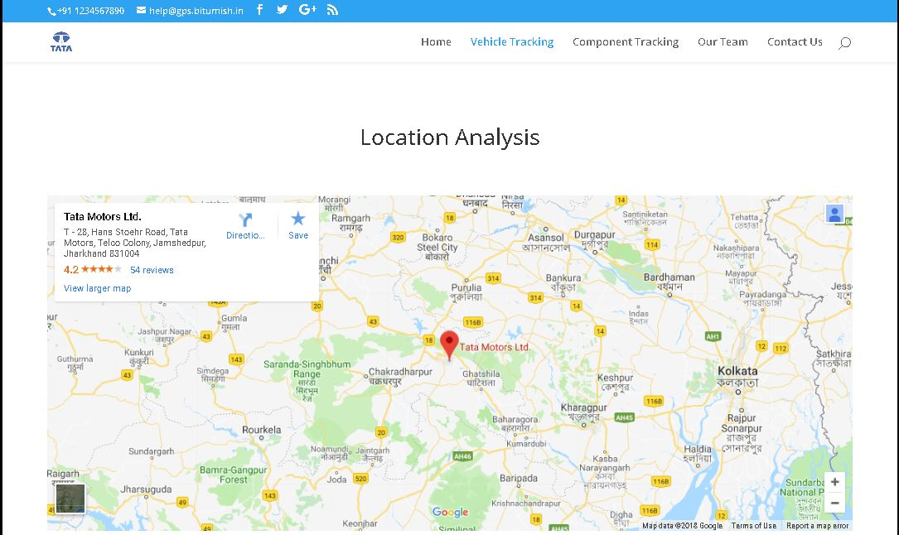Fig 12: Vehicle Tracking

Fig 13: Speed Analysis

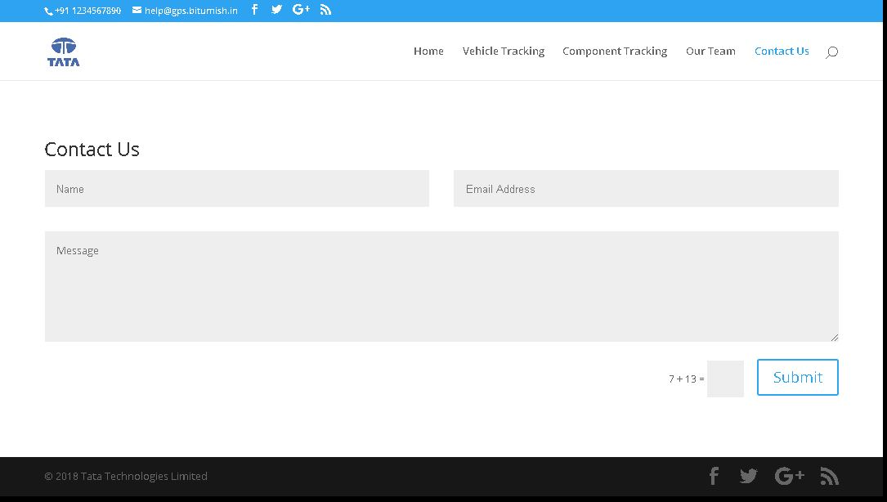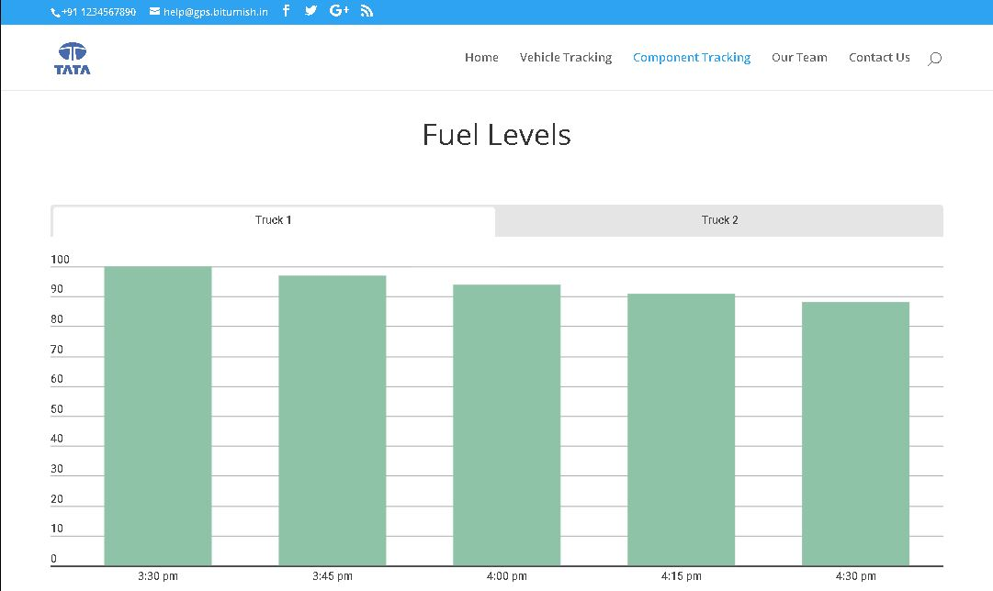Fig 14: Fuel Tracking

Fig 15: Contacts and help centre

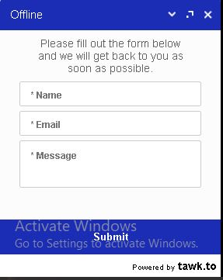

Fig 16: Chatting System

**ADVANTAGES:**

* **REDUCING FUEL COSTS:**

Almost everything monitored by GPS vehicle tracking solutions can work to help reduce fuel costs. Speeding is a huge factor in high fuel usage. Maintaining proper speeds can significantly reduce the amount of fuel used by your vehicles. Many telemetric solutions provide speed information and alert you when a truck exceeds set speed thresholds.

Excessive idling can contribute to high fuel costs for many businesses. When drivers unproductively waste fuel by using their truck as a climate control system, you lose money from your bottom line. Fleet tracking solutions can help reduce idling times by alerting you when vehicles idle longer than a preset duration so you can take corrective action.

* **IMPROVING DRIVER BEHAVIOUR:**

Other major contributors to high fleet costs are unauthorized vehicle usage and improper driver behaviour. GPS vehicle tracking solutions can relay a variety of information regarding driving behaviour including speed, engine start-up and shut-down times and idling time. This information can be used to enforce driving policy and curb unwanted behaviour like excessive speeding, tardiness and extended idling. Studies show that tracking your vehicles encourages employees to work more effectively and stop utilizing company trucks for personal use.

* **INCREASING SAFETY AND SECURITY :**

GPS vehicle tracking solution can also help improve the security of your fleet. In the event a vehicle is stolen, a hidden GPS receiver can help you recover an asset and any onboard equipment or inventory quickly. In addition, some systems offer features that alert owners immediately if a vehicle is used during off-hours.

Some telemetric providers feature alerting functions to let you know when vehicles are due for routine maintenance. Proper maintenance ensures that your fleet is compliant with safety guidelines and can help reduce repair costs in the long run.

* **BEST CUSTOMER SERVICE :**

With proper mapping software, fleet owners and managers know the exact location of every vehicle in their fleet. This gives dispatchers the ability to effectively direct drivers to any job site. In addition, you can locate and dispatch the closest vehicle to any job site. GPS vehicle tracking provides better routing and dispatching which reduces fuel usage, reduces truck mileage and increases the number of jobs completed in a day. Fleet tracking solutions can incorporate a number of features that help improve customer service. Better routing and dispatching helps you get to your customers more quickly. You will also be able to determine when a truck arrived on a job and when it left, providing accurate and verifiable proof of services.

* **IMPORTANCE OF MAPPING:**

Fleet tracking requires current and clear mapping. Some solutions have partnered with well-known mapping providers for the most accurate and up-to-date mapping available. The best mapping features allow you to zoom all the way down to street level and provide street, terrain, satellite and hybrid street/satellite views. In addition, you should be able to get real-time traffic information via the mapping in order to help drivers avoid delays.

* **USING REPORTS AND ALERTS :**

GPS fleet tracking solutions, like the Reveal platform allow you to automate concise and easy-to-understand reports on a weekly or monthly basis. In addition, you have the ability to generate reports instantly. The data can be organized to give you information about daily vehicle or driver activity, speeding violations, violations of company driving policy, a complete list of jobs, excessive idling times and much more.

GPS fleet tracking solutions also have extensive historical reporting functions. You can access GPS information gathered by your solution from the time you started using it. You can compare the performance between two employees, or compare an employee’s performance against the company average in areas such as speeding, idling, miles driven and engine-on or off times.

**DISADVANTAGES**

* An Arduino is a microcontroller motherboard. A microcontroller is a simple computer that can run one program at a time, over and over again. It is very easy to use. A Raspberry Pi is a general-purpose computer, usually with a Linux operating system, and the ability to run multiple programs. Therefore, Arduino itself is a drawback for this project.
* Device cannot operate upon harsh weather conditions as there can be server lag, less signal strength.
* Security: IOT devices are often vulnerable to security breaches because of poor design.
* Sometimes the GPS may fail due to certain reasons and in that case you need to carry a backup map and directions.
* Loose connection was one of the major problems which we faced while working for this project. It was very difficult to identify which wire was having loose connection.

**CONCLUSION**

Tata Technologies Ltd has given me a clear view of the lifestyle of an application development-starting right from conceptualization, through analysis, design and development.

The development of the IOT project and web-application has been a challenging as well as an enriching experience for me. During this tenure, not only did I come across many new concepts but I also imbibed many work-healthy virtues like responsibility and team work, for instance. This experience shall help me improve my professionalism in the long run.

Also constant help from my project guide as well as my team members have converted this tenure to a lifetime experience for me. I realized how important it is to practically apply and develop a system using the theory I have learned in class.

In a nutshell it was a new and enriching experience for me, and I shall always keep up the good work culture that I have learned from my days in here.

**BIBLIOGRAPHY**

The following sources have been referred to, for the completion of this report:

* [**www.tutorialspoint.com**](http://www.tutorialspoint.com/)
* [**www.stackoverflow.com**](http://www.stackoverflow.com/)
* [**http://php.net/manual/en/index.php**](http://php.net/manual/en/index.php)
* **www.Arduino.cc**
* [**www.github.com**](http://www.github.com)
* **IOT AUTOMATIONS by Jerker Delsing**
* **The Technical Foundations Of IOT**